Supporting document 1

Proposal P1037 – Amendments associated with Nutrition Content & Health Claims

Trademarked elements of the Health Star Rating (HSR) system

The following elements of the HSR system are trademarked:

- Star rating (Trademark 1641447)
- Star rating together with the energy icon (Trademark 1641445)
- Star rating together with the energy icon and prescribed saturated fat, sugar and sodium nutrient icons (Trademark 1641446).

Each trademark covers the images for the ten different star ratings from a half star to five stars. Examples of these trademark images are illustrated below.
Diagram 1 Trademark example of the star rating
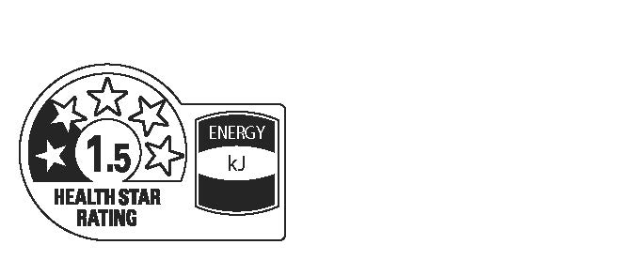
Diagram 2 Trademark example of a single energy icon with the star rating

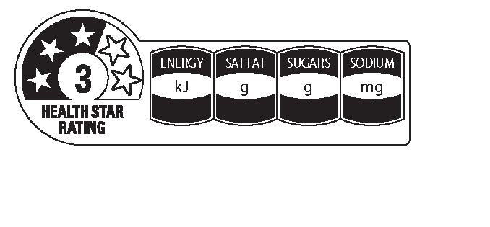
Diagram 3 Trademark example of prescribed energy, saturated fat, sugar and sodium icons with the star rating
Optional positive nutrient icons (for example, for fibre, protein, or certain vitamins or minerals) are not included in any of the trademarks. The trademarks do not include the percentage daily information (%DI). Additionally, the use of ‘high’ descriptors for optional positive nutrient icons and ‘low’ descriptors for prescribed nutrient icons are not included in the trademarks.

The Front-of-Pack Labelling Secretariat within the Australian Department of Health has launched a website to provide further information about the HSR system to stakeholders. The website includes a link to the HSR System Style Guide, which provides further detail about the principles of use for this voluntary system.

http://www.healthstarrating.gov.au/internet/healthstarrating/publishing.nsf/content/home

